# Network Address Translation

## Revisiting IP Addresses

* Most IP addresses are public
  + they uniquely identify a node on the Internet; i.e. known to the outside world
  + can be routed on the Internet
* Certain groups of IP addresses are private
  + not known to the outside world (e.g. outside of an org or a private home net)
  + cannot be routed on the Internet

## Private IP Addresses

* Private IP address ranges (IPv4):
  + 10.0.0.0/8
    - 10.0.0.0 – 10.255.255.255
  + 172.16.0.0/12
    - 172.16.0.0 – 172.31.255.255
  + 192.168.0.0/16
    - 192.168.0.0 – 192.168.255.255
  + If you assign a node with any of these addresses, they are not meant to be seen by the outside world

## Network Address Translation (NAT)

* Remember, concept is that local net, including all its devices, uses just one IP address as far as outside world is concerned; devices inside are not addressable.
* Used by most firewalls to shield a private network from the outside Internet
  + translates between private addresses inside the net and public addresses outside the net
  + done transparently, internal IP addresses remain hidden
* Performed by NAT proxy servers/router
  + uses an address table to do translations
    - one-to-one mapping: replace a private ‘internal’ address with public ‘outside’ address
    - one-to-many mapping: map multiple private hosts to one publicly exposed IP address
    - performs reverse operations for response packets

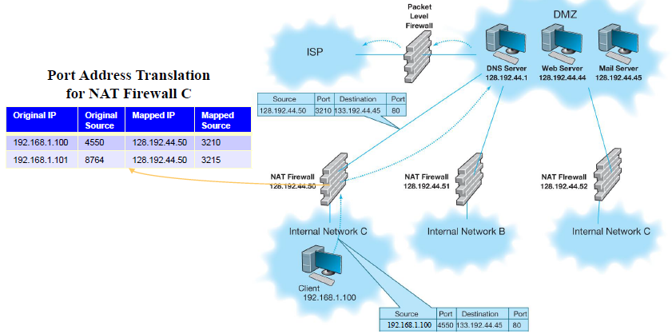  
example of network with NAT

## Using Private Addresses with NAT

* Used to provide additional security
* Assigns private IP addresses to devices inside the network
  + Even if they are discovered, no packets with these addresses will be delivered (publicly illegal IP address)
* Example:
  + Assigned public address: 128.192.55.xx
  + Assign to NAT proxy server: 128.192.55.1
  + Assign to internal computers: 10.3.3.xx
    - 10.x.x.x is never used on Internet
  + Private address hidden from outside world
* Additional benefit is that it gives ability to have more internal IP addresses for an organization
  + Save IPv4 address exhaustion